|  |  |  |
| --- | --- | --- |
| Write an application in C++ to read a file name as command line argument and to process and extract the user, host and domain names.Perform the specified operations: | | |
| Requirement Tag | Requirement Description | Comments |
| FSTR/01 | Open file, read each line containing email id and display. Handle errors if any. |  |
| FSTR/02 | Extract username, host and domain name from all valid email id’s . (Consider only domain names as .com or .edu as valid domains) | Hint:  1. For invalid domain names or for missing fields, display error message accordingly and ignore entry.  2. For valid entry, use a structure or class with username, host and domain name members. Create an object and initialize with extracted email detail. |
| FSTR/03 | Display valid email id’s |  |

1. Open file, read each line containing email id and display. Handle errors if any.

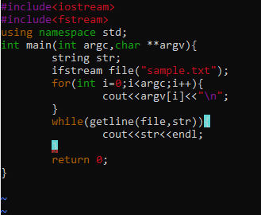

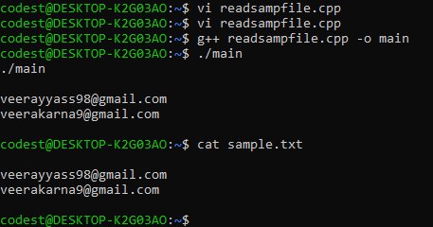

1. Extract username, host and domain name from all valid email id’s . (Consider only domain names as .com or .edu as valid domains).

